Table of Contents
1 Introduction 1
1.1 Purpose 1
1.2 Document Conventions 2
1.3 Intended Audience and Reading Suggestions 3
1.4 Product Scope 4
2 Overall Description 5
2.1 Product Perspective 5
2.2 Product Functions 6
2.3 User Classes and Characteristics 7
2.4 Operating Environment 8
2.5 Design and Implementation Constraints 9
2.6 User Documentation 10
2.7 Assumptions and Dependencies 11
3 External Interface Requirements 12
3.1 User Interfaces 12
3.2 Hardware Interfaces 13
3.3 Software Interfaces 14
3.4 Communications Interfaces 15
4 System Features 16
4.1 System Feature 1 – User Account & Profile Management 16
4.1.1 Description and Priority 16
4.1.2 Stimulus/Response Sequences 16
4.1.3 Functional Requirements 16
4.2 System Feature 2 – Lesson, Level & Progression Management 17
4.2.1 Description and Priority 17
4.2.2 Stimulus/Response Sequences 17
4.2.3 Functional Requirements 17
4.3 System Feature 3 – Quiz & Coding Assessment System 18
4.3.1 Description and Priority 18
4.3.2 Stimulus/Response Sequences 18
4.3.3 Functional Requirements 18
4.4 System Feature 4 – 2D Battle Game Module 19
4.4.1 Description and Priority 19
4.4.2 Stimulus/Response Sequences 19
4.4.3 Functional Requirements 19
4.5 System Feature 5 – NPC Tutor (AI Assistant) 20
4.5.1 Description and Priority 20
4.5.2 Stimulus/Response Sequences 20
4.5.3 Functional Requirements 20
4.6 System Feature 6 – Admin Panel 21
4.6.1 Description and Priority 21
4.6.2 Stimulus/Response Sequences 21
4.6.3 Functional Requirements 21
5 Other Nonfunctional Requirements 22
5.1 Performance Requirements 22
5.2 Safety Requirements 22
5.3 Security Requirements 22
5.4 Software Quality Attributes 23
5.5 Business Rules 24
6 Other Requirements 25
6.1 Appendix A: Glossary 25
6.2 Appendix B: Analysis Models 26
6.2.1 Work Breakdown Structure (WBS) 26
6.2.2 Entity Relationship Diagram (ERD) 27
6.2.3 Use Case Diagram 28
6.2.4 Activity Diagram 29
6.2.5 Sequence Diagram 30
6.2.6 Collaboration Diagram 31
6.2.7 High-Level Design (HLD) 32
• Use Case 2: Start a Level 32
• Use Case 3: Lesson 32
• Use Case 4: Attempt Test 33
• Use Case5: Submit Code 33
• Use Case 7: NPC Tutor 34
6.2.8 UML Class Diagram 35
6.3 Appendix C: To Be Determined (TBD) List 36
7 References 37
8 Prototype: 38
8.1 Wireframes – (User Side) 38
8.1.1 Register 38
8.1.2 Login Page 39
8.1.3 Home Page 40
8.1.4 Lesson Page 41
8.1.5 About Us Page 42
8.1.6 Contact Us Page 43
8.1.7 Coding Page 44
8.1.8 Testing Page 45
8.2 Wireframe – (Admin Side) 46
8.2.1 Admin Dashboard Page 46
8.2.2 Admin Users Page 46

Figure 1: WBS 26
Figure 2:ERD 27
Figure 3:UML Class diagram 28
Figure 4Activity Diagram 29
Figure 5: Sequence Diagram 30
Figure 6: Collaboration Diagram 31
Figure 7: UML Class diagram 35
Figure 8:Register Page 38
Figure 9:Login Page 39
Figure 10: Home Page 40
Figure 11: Lesson Page 41
Figure 12:About Us Page 42
Figure 13: Contact Us Page 43
Figure 14:Coding Page 44
Figure 15:Test Page 45
Figure 16: Admin Dashboard Page 46
Figure 17: Admin Users Page 46

No table of figures entries found.

Introduction

Purpose
This Software Requirements Specification (SRS) outlines the non-functional and functional requirements of the CODEQUEST application which is a web-based learning platform, based on the game system, that aims to teach C# programming language to learners. The purpose of this SRS is to:
- Outline the requirements and limitations of CODEQUEST to developers, testers and stakeholders.
- Act as a contract between the student developer, supervisors and academic institution on what this system will accomplish.
- Give a justification to system design, implementation and testing.
- The system addressed by this SRS is the whole CODEQUEST, which includes Blazor, MAUI, HTML, CSS, based frontend web. ASP.NET Core Backend services.
- Detection of a C# code analysis [Roslyn].
- Connection to a LLM API (e.g. OpenAI) to the NPC tutor.
- DB on the user, lessons, tests, progress, and battle information.

Document Conventions
- Requirements Identification
  - Functional requirements: REQ-FUNC-XX
  - Non-functional requirements: REQ-NF-XX
  - Interface requirements: REQ-INT-XX
  - Business rules: BR-XX
- Priority Levels
  - High (H) – Must be implemented for system acceptance.
  - Medium (M) – Important but may be deferred to later iterations.
  - Low (L) – Nice to have; can be implemented if time and resources permit.
- Typography (for the written document)
  - Italics – explanatory notes, examples.
  - Bold – keywords, core concepts.
  - Monospace – requirement IDs and technical terms when needed.

Intended Audience and Reading Suggestions
The SRS is intended for:
- Student developer – to understand all system requirements and guide implementation.
- Internal supervisor (Mr. Kushal Tamang) – to review technical feasibility and project scope.
- External supervisor (Mr. Samuel Sherpa) – to review industry relevance and practicality.
- Module leader / examiners – to assess whether the project meets academic requirements.
- Future developers or maintainers – to extend or maintain the system post-FYP.
- Testers / QA – to design test cases based on clear, verifiable requirements.
- Recommended reading order:
  - All readers: Sections 1 and 2 for an overview.
  - Developers & testers: Sections 3 and 4, plus Appendix B (analysis models).
  - Supervisors & examiners: Sections 1, 2, 3, 4, 5, and 6.

Product Scope
CODEQUEST is a gamified C# learning platform that:
- Presents short, structured lessons on C# topics (syntax, control flow, OOP, collections, etc.).
- Provides tests and coding exercises by the end of every lesson.
- Relates the performance in the assessment to a straightforward 2D battle game, in which accurate responses harm an enemy and the wrong ones the player or hints.
- Includes AI-based NPC tutor that explains mistakes and challenging concepts in the case of needing assistance.
- Uses the Roslyn compiler on the backend to analyze user-submitted C# code and provide syntax-friendly feedback.
Intended benefits:
- Make C# learning interesting, interactive, and less frightening to first timers.
- Help students build confidence and understanding through feedback-driven practice.
The system supports academic goals for the Final Year Project by demonstrating:
- Full-stack web development (React + ASP.NET Core).
- Integration of compiler technology (Roslyn).
- Application of AI services (LLM API) into the educational setting
- Application of Agile methodology at iterative level of development.

Overall Description

Product Perspective
CODEQUEST is a new, self-contained web application developed as a Final Year Project It does not displace any of the current institution-wide systems but can be applied as an additional learning tool.
High-level components:
- Frontend (React)
  - Offers the UI to the lessons, quizzes, 2D-battling view, and the 2D-codifying editor.
- Backend (ASP.NET Core)
  - RESTful APIs have been made public to authorize, lessons and quizzes, battles and interaction with tutors, and progress.
- Code Analysis Module (Roslyn)
  - Analyzes C# code submissions, both syntactically and simply semantically correct..
- AI Tutor Module (LLM API)
  - Sends explanations and hints requests to external AI service (e.g., OpenAI API)
- Database (SQL Server or PostgreSQL)
  - Stores lessons, progress, tests, code submissions, attempts, progress, stores users.
The ERD in Appendix B describes the main entities such as User, Level, Test, Question, Attempt, CodeSubmission, and Battle, and their relationships.

Product Functions
At a high level, CODEQUEST will provide the following functions:
- User registration and login.
- Watching lessons on C# learning by subject and grade.
- Taking quizzes and coding issues.
- It involves battle with 2D style art where the score in quizzes influences the health of the player and the opponent.
- Writing C# code and getting returns in the form of automated feedback on Roslyn.
- Getting hints and explanations regarding one’s context provided by an AI tutor.
- Admission to an administrative user where he can update and administer the content (lessons, quizzes, tests and game parameters).
- Monitoring the progress, scores, and the number of attempts at various levels of the users.

User Classes and Characteristics
- Student (Learner)
  - Primary user.
  - Novice or C# intermediate learner.
  - May has limited experience in programming.
  - Reads lessons on the platform, does quizzes, submits code, and fights battles.
  - Needs a straightforward, easy-to-use, and accommodating interface.
- Admin
  - Content manager, instructor or supervisor
  - Has access to admin panel.
  - Lectures lessons, quizzes, tests, and game settings.
  - May monitor user progress.
- System / NPC Tutor (AI)
  - An automated actor and not a human user.
  - Gives explanations and hints as a response to student difficult in situations.
  - Communication through the UI and the backend.

Operating Environment
- Client-side
  - Modern web browser ( Chrome, Edge, Firefox)
  - Have to be connected to the internet with a desktop or a laptop.
- Server-side
  - ASP.NET Core runtime (.NET 6 or above)
  - Hosting environment: Windows or Linux server (e.g., IIS, Kestrel, or containerized via Docker)
  - Database: SQL server or postgreSQL.
  - External AI API endpoint which can be accessed through HTTPS.

Design and Implementation Constraints
- The system must be implemented with:
  - React for the frontend.
  - ASP.NET core, backend applications.
  - A database (relational: e.g. SQL Server / PostgreSQL).
- Roslyn
  - Used for C# code analysis at least at the syntax-checking level.
- An external LLM API (e.g., OpenAI) will be used;
  - API-keys should not be visible to the frontend.
- Time constraints due to FYP schedule limit the scope of:
  - Advanced or sophisticated graphics (battle will be easy in 2D and minimal effects).
  - Deep AI personalization (the first version is concerned with simple guidance)
- Institutional constraints:
  - The project must be portrayed in a laboratory setting.
  - Poaching and school policy regulations should be admired regarding outsourcing

User Documentation
Planned documentation:
- User Guide (for students):
  - Registration, navigation, navigation between levels, taking tests, code editor, and feedback interpretation.
- Admin Guide:
  - How to enter as the administrator, create/edit the lesson, add the question, set the battle parameters.
- Technical Documentation:
  - ERD, use case diagrams, API endpoints, and system architecture (included in FYP report).
  - The documentation will be provided as PDF and may be integrated as the help pages in the web app

Assumptions and Dependencies
Assumptions:
- The users are computer literate to a minimal level and capable of using a web browser.
- When using the system, one has access to an internet connection.
- External AI API: a responsive API is provided when using the AI.
- The user number of the FYP prototype will be low (e.g., less than 500
Dependencies:
- Availability and reliability of:
  - Database server
  - AI API service
  - back-end hosting environment.
- Proper installation of the SDK of .NET, development tools and necessary libraries.

External Interface Requirements

User Interfaces
In the system, the following logical user interface components shall be provided:
- Login / Register Page
  - Fields email/username, password, confirm password (registration).
  - Actions: Login, Register, Forgot Password (no prototype).
- Dashboard / Home
  - Displays the levels available, the progress, and last lesson visited by the user.
- Lesson View
  - Presents instructional material (text, examples, may be simple diagrams).
  - Navigation: Previous/Next lesson, “Start Test” / “Start Battle”.
- Quiz & Coding View
  - Multiple choice and short answer questions.
  - Coding any IDE embedded coder.
  - Submit button to check answers or to check code
- Battle Screen
  - Displays both play and monster health point’s (HP).
  - Displays last action result (e.g., “Correct answer: Player attacks for 10 damage”).
  - Graphical representation of the win/lose status and the ability to re-try or proceed.
- NPC Tutor Panel
  - Hints and explanations interface in the style of a chat.
  - Will be present when the user makes several tries or asks to be assisted.
- Admin Panel
  - Level/ lesson/test/question creation and editing forms.
  - Table lists of viewable content (edit/delete actions).
- UI guidelines:
  - Regular navigation menu and design.
  - Bold call-to-action buttons (e.g. “Submit”, “Retry Level”, “Ask Tutor”).
  - Students should be able to read the error messages and not technical.

Hardware Interfaces
The system does not require direct hardware interfaces beyond:
- Standard input/output devices (keyboard, mouse, display).
- Access to ORM or standard DB client (e.g. Entity Framework).
- Places User, Level, Test, Question, Attempt, CodeSubmission, and Battle.

Software Interfaces
- Database (SQL Server / PostgreSQL)
  - Access via ORM or standard DB client (e.g., Entity Framework).
  - Stores entities such as User, Level, Test, Question, Attempt, CodeSubmission, Battle.
- Roslyn Compiler Platform
  - Integrated in the backend to:
    - Parse and compile C# code.
    - Detect syntax errors and basic issues.
- LLM API (e.g., OpenAI)
  - REST API over HTTPS.
  - Input: user question, context (level, last error, code snippet).
  - Output: explanation/hints as text.
- Optional Email Service (for account verification / password reset – may be out of scope for prototype):
  - SMTP or email API (SendGrid, etc.).

Communications Interfaces
- All communication between frontend and backend will use HTTPS with JSON-based REST APIs.
- Expected communication patterns:
  - POST /api/auth/login – user authentication.
  - GET /api/lessons/{levelId} – fetch lessons.
  - POST /api/tests/{testId}/submit – submit quiz or code answers.
  - POST /api/tutor/ask – send user query to NPC tutor.
- Data transfer:
  - UTF-8 encoded JSON.
  - Secure transmission using TLS (where possible).
- Communication with AI and other external services also uses HTTPS according to provider standards.

System Features
Each feature includes a description, key stimulus/response sequences, and functional requirements.

System Feature 1 – User Account & Profile Management

Description and Priority
This feature allows users to register, log in, and maintain a profile so their progress, scores, and attempts can be tracked.
- Priority: High

Stimulus/Response Sequences
- Stimulus: New user chooses “Register” and submits required details.
  - Response: System validates input, creates a new user record, and redirects to dashboard.
- Stimulus: Returning user submits correct login credentials.
  - Response: System authenticates user, creates a session/token, and shows their dashboard.
- Stimulus: User enters invalid credentials.
  - Response: System displays a clear error message and does not log them in.

Functional Requirements
- REQ-FUNC-01: The system will enable users to join with at least unique email address and password.
- ORY: Requirement: The system will verify registration requirements (e.g. non-empty, password length).
- REQ-FUNC-03: The system will include password encryption or hashing of user passwords and store them.
- REQ-FUNC-04: The system will permit users to log-in with the help of their registered credentials.
- Postcondition: The system will retain a user session/Token on successful log in.
- REQ-FUNC-06: The system will provide the possibility to assign an administrative function to users.

System Feature 2 – Lesson, Level & Progression Management

Description and Priority
This feature structures the learning journey into levels and lessons, covering topics from basic C# syntax to OOP and collections.
- Priority: High

Stimulus/Response Sequences
- Stimulus: Student selects a level on the dashboard.
  - Response: System loads the associated lessons and shows progress within that level.
- Stimulus: Student completes a level’s battle successfully.
  - Response: System marks that level as completed and unlocks to the next level.

Functional Requirements
- REQ-FUNC-07: The system will classify the contents by levels and lessons.
- REQ-FUNC-08: The system will enable the user to access lessons with respect to a selected level.
- REQ-FUNC-09: The system will keep a record of the completion status of every level per user.
- REQ-FUNC-10: The system will open the next level only upon the completion of the requirements of the preceding level (e.g. passing the test / winning the battle).
- REQ-FUNC-11: Admin will be in a position to create or update or delete the levels and lessons.

System Feature 3 – Quiz & Coding Assessment System

Description and Priority
This feature delivers quizzes and coding tasks to evaluate learning. Assessment outcomes drive both learning feedback and game mechanics.
- Priority: High

Stimulus/Response Sequences
- Stimulus: Student starts a test for a level.
  - Response: System loads the questions and any associated coding tasks.
- Stimulus: Student submits answers and code.
  - Response: System evaluates the answers, runs code checks, and returns a score and feedback.

Functional Requirements
- REQ-FUNC-12: There will be at least 1 quiz or a coding question in every lesson.
- REQ-FUNC-13: The system will have a series of multiple choice and/or short-answer questions.
- REQ-FUNC-14: The system will have a built-in code editor that will be used to code.
- REQ-FUNC-15: The system will mark quiz answers and check whether the answers are correct.
- REQ-FUNC-16: The system will pass code written in C# to the Roslyn module to undergo analysis.
- REQ-FUNC-17: The system will provide feedback when both the user commits errors, and the feedback will be a hint or some explanation (it could be through the NPC tutor).
- REQ-FUNC-18: The administrator will have the capability to generate, revise and delete tests and questions

System Feature 4 – 2D Battle Game Module

Description and Priority
This feature links educational performance to a simple 2D battle system where correct answers allow the player to attack an enemy, and incorrect answers cause the player to take damage or trigger hints.
- Priority: Medium–High

Stimulus/Response Sequences
- Stimulus: Student answers a quiz question correctly.
  - Response: Player’s character performs an attack; enemy HP decreases.
- Stimulus: Student answers a question incorrectly.
  - Response: Enemy attacks; player HP decreases, and a hint may be displayed.
- Stimulus: Enemy HP reaches zero.
  - Response: System declares victory, marks level as completed, and unlocks the next level.
- Stimulus: Player HP reaches zero.
  - Response: System declares defeat, logs an attempt, and offers retry and/or NPC tutor help.

Functional Requirements
- REQ-FUNC-19: Battle scenarios representing each of the levels shall be present.
- REQ-FUNC-20: The system will be able to maintain HP values of an enemy and player in a battle.
- Requirements: When the student answers a question correctly, the system will reduce the enemy HP.
- REQ-FUNC-22: The system will make the player lose the required amount of HP when the student provides an incorrect answer to a question.
- REQ-FUNC-24: Ending of battle takes place when either the player or the enemy has a zero HP.
- REQ-FUNC-24: The system will keep a record of every attempt at a battle and the result

System Feature 5 – NPC Tutor (AI Assistant)

Description and Priority
The NPC tutor provides AI-generated hints, explanations, and guidance when students struggle with lessons, tests, or code submissions.
- Priority: High (core differentiator)

Stimulus/Response Sequences
- Stimulus: Student fails a level multiple times or presses a “Ask Tutor” button.
  - Response: System sends relevant context (question, last code attempt, errors) to the LLM API, then displays a helpful explanation or hint.

Functional Requirements
- REQ-FUNC-25: The system will give an interface where the NPC tutor will be questioned by the students.
- REQ-FUNC-26: When calling the help, the system will provide the contextual data (e.g., current test, error messages) to the AI API.
- REQ-FUNC-27: The system will show AI generated responses in a student friendly readable format.
- REQ-FUNC-28: The system will restrict the calls of the AI at a time to aid in cost-control.
- REQ-FUNC-29: In case the AI API is not available, the system should include fallback hints which are statical.

System Feature 6 – Admin Panel

Description and Priority
This feature allows admin users to set up and maintain lessons, tests, game attributes, and possibly review user progress.
- Priority: Medium

Stimulus/Response Sequences
- Stimulus: Admin logs into the system.
  - Response: System verifies admin role and displays admin dashboard.
- Stimulus: Admin creates a new level with lessons and tests.
  - Response: System validates and stores the new content, making it available to students.

Functional Requirements
- REQ-FUNC-30: The system will have an administrative only dashboard.
- REQ-FUNC-31: The system will enable admins to add, edit and remove lessons,test and questions.
- REQ-FUNC-32: System will enable admins to set up battle specifications (e.g., HP initial, harm by responding to correct answer).
- REQ-FUNC-33: The system can enable admins to see basic user progress break-downs (not mandatory in the prototype).

Other Nonfunctional Requirements

Performance Requirements
- REQ-NF-01: Lesson and quiz pages should load within 3 seconds on a typical broadband connection.
- REQ-NF-02: Code analysis feedback from Roslyn should be returned within 5 seconds for typical student submissions.
- REQ-NF-03 Covers: The AI tutor responses are expected to be given back within 10 seconds, when given out in a network.
NOTE: This requirement is necessary because the system must sustain a minimum of 20 simultaneous users in the FYP prototype environment without collapsing.

Safety Requirements
The system does not control physical devices and does not pose physical safety risks.
- REQ-NF-05: The system will ensure that it will not lose data in key processes like registration and submission of tests because transactions will be utilized where feasible.
- REQ-NF-06: The users will be told in clear messages not to provide sensitive personal information to the AI tutor.

Security Requirements
- REQ-NF-07: Passwords will be hashed and salted, and then stored.
- REQ-NF-08: HTTPS shall be used to communicate between the client and the server on the initial deployment.
- REQ-NF-09: The functionality of the Administration will only be provided to be authorized by roles.
- REQ-NF-10: API keys should be stored in the server, but never presented to the frontend.
- REQ-NF-11: the system will safeguard simple threats like SQL injections and XSS with parameterized queries and output encoding.

Software Quality Attributes
- Usability
  - REQ-NF-12: The UI will be easily understandable by beginning users with clear labelling and without using any unnecessary specific terms.
  - REQ-NF-13: Navigation will be page consistent
- Reliability
  - REQ-NF-14: The system will support graceful failure of temporary AI API with fallback hints.
- Maintainability
  - REQ-NF-15: The codebase shall be modular, separating concerns (frontend, backend, AI integration, code analysis).
- Portability
  - REQ-NF-16: The system is to be compatible with both Windows and Linux servers (with the help of the cross-platform capabilities of the .NET Core).
- Testability
  - REQ-NF-17: The main functions (authentication, quiz evaluation, battle logic) will be unit-testable.

Business Rules
- BR-01: A student must pass the level test/battle before the next level becomes available.
- BR-02: A failed attempt should not erase previous completed levels.
- BR-03: Admins are the only users allowed to modify content (lessons, tests, game parameters).
- BR-04: The number of AI tutor calls per user per day may be limited (e.g., 10) to manage API usage.

Other Requirements
- Logging & Monitoring
  - The system should log critical operations (login failures, API errors, code analysis errors) for debugging.
- Internationalization
  - Initial version will be in English only.
- Legal & Ethical
  - The platform should include a basic disclaimer that it is an educational prototype, not a commercial product.
  - Any personal data used must comply with basic privacy principles (no unnecessary data collection).

Appendix A: Glossary
- AI – Artificial Intelligence
- API – Application Programming Interface
- ASP.NET Core – Web framework for building backend services in .NET
- Attempt – A student’s single try at a test or level.
- Battle – A simple 2D encounter where player and enemy HP change based on quiz performance.
- C# – C-Sharp programming language
- CodeSubmission – A record of code submitted by a student for evaluation.
- ERD – Entity Relationship Diagram
- FYP – Final Year Project
- HP – Hit Points (health value of player or enemy)
- Level – A set of lessons and tests grouped by difficulty/topic.
- LLM – Large Language Model (e.g., OpenAI)
- NPC – Non-Player Character (here, AI tutor)
- Roslyn – .NET Compiler Platform for C#
- SQL – Structured Query Language
- SRS – Software Requirements Specification
- Test – A set of questions and/or coding tasks used to assess understanding.

Appendix B: Analysis Models
These are referenced from your proposal, diagrams themselves are not redrawn here, but the SRS acknowledges them.

Work Breakdown Structure (WBS)
A WBS provides a hierarchical view of your project’s scope, translating overall strategies and objectives into specific goals, workflows, project phases, and action plans.
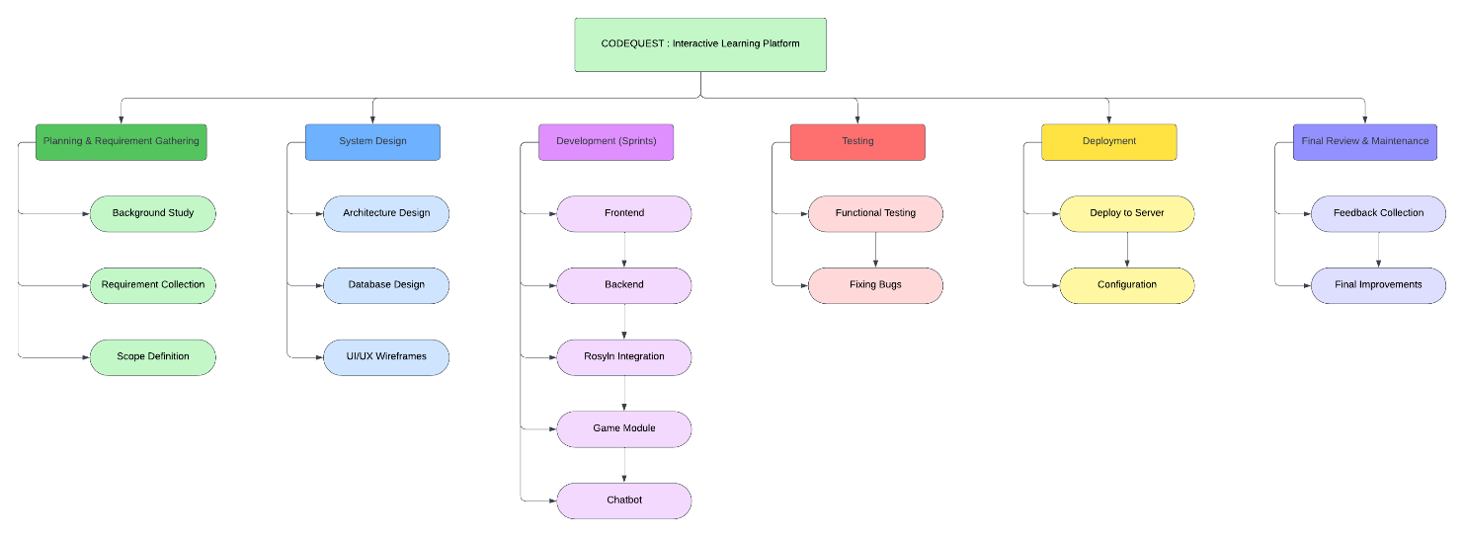
Figure 1: WBS

Entity Relationship Diagram (ERD)
  - Entities: User, Level, Test, Question, Attempt, CodeSubmission, Battle.
  - Key relationships (from your proposal):
    - One User - many CodeSubmissions.
    - One Level - many CodeSubmissions.
    - One Test - many CodeSubmissions.
    - One User - many Attempts.
    - One Test - many Attempts.
    - One Attempt - one Battle.
    - One Level - many Tests.
    - One Test - many Questions.
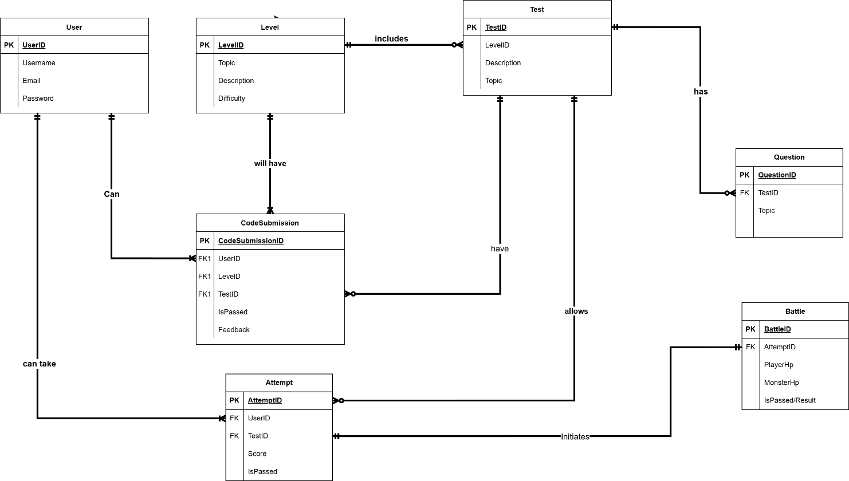
Figure 2:ERD

Use Case Diagram
These use cases represent the core functionalities of the CODEQUEST system. Students can register/login, begin levels, view lessons, attempt tests, submit code, and receive help from the NPC Tutor. The system validates user details and submits code automatically. Admins manage the learning content and maintain system resources.
  - Actors: Student, Admin, System.
  - Main use cases:
    - Login/Register User
    - Start a Level
    - View Lesson
    - Attempt Test
    - Submit Code
    - Validate Code
    - NPC Tutor Help
    - Admin Manage Content
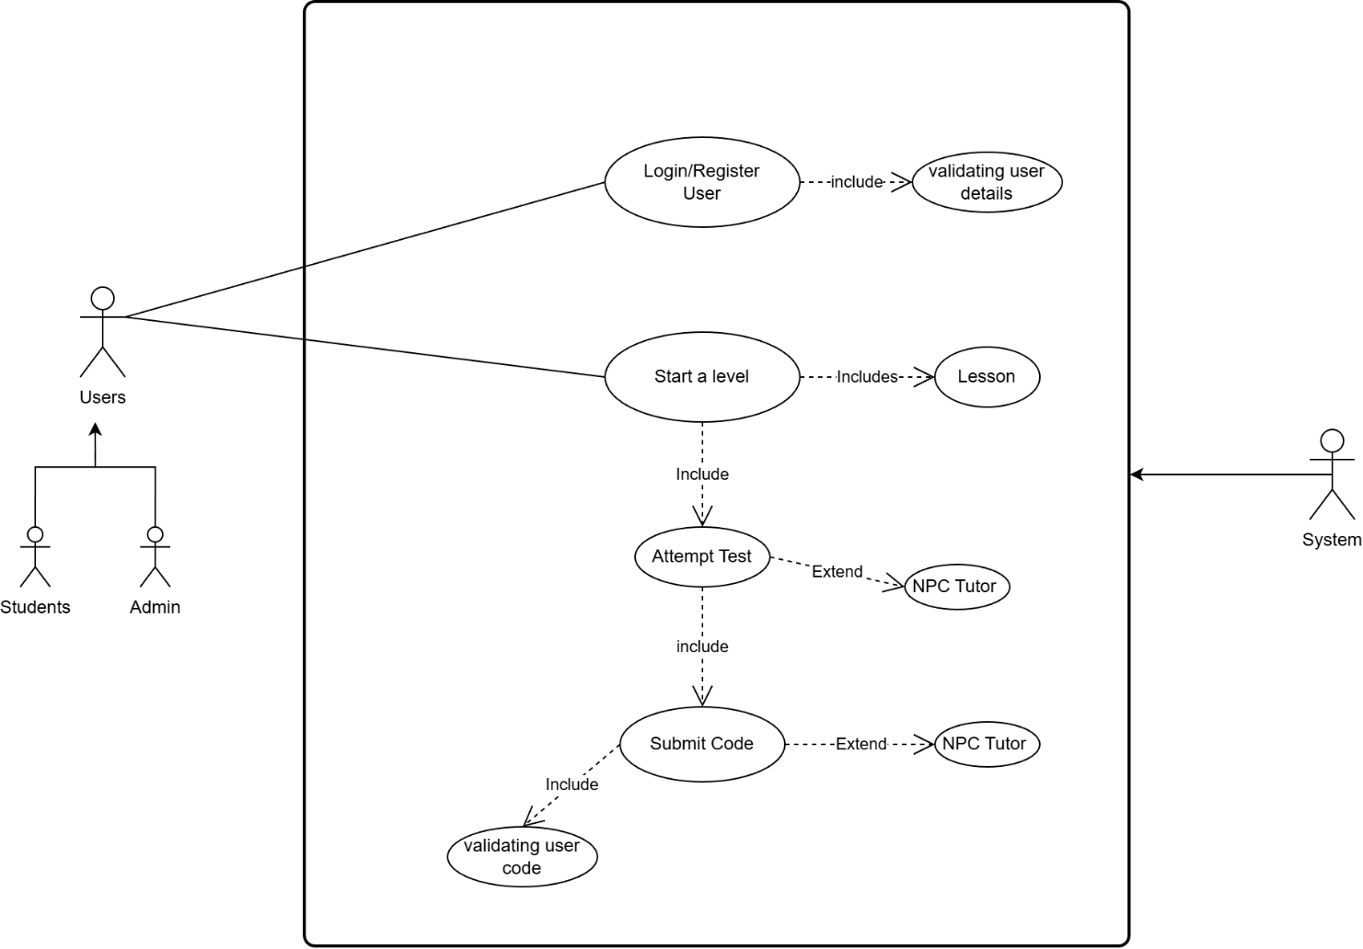
Figure 3:UML Class diagram

Activity Diagram
Activity Diagram is a UML tool used to model the workflow or processes in a system. It represents the flow of activities and decisions visually, helping developers understand the dynamic aspects of a system. (visualparadigm, 2025)
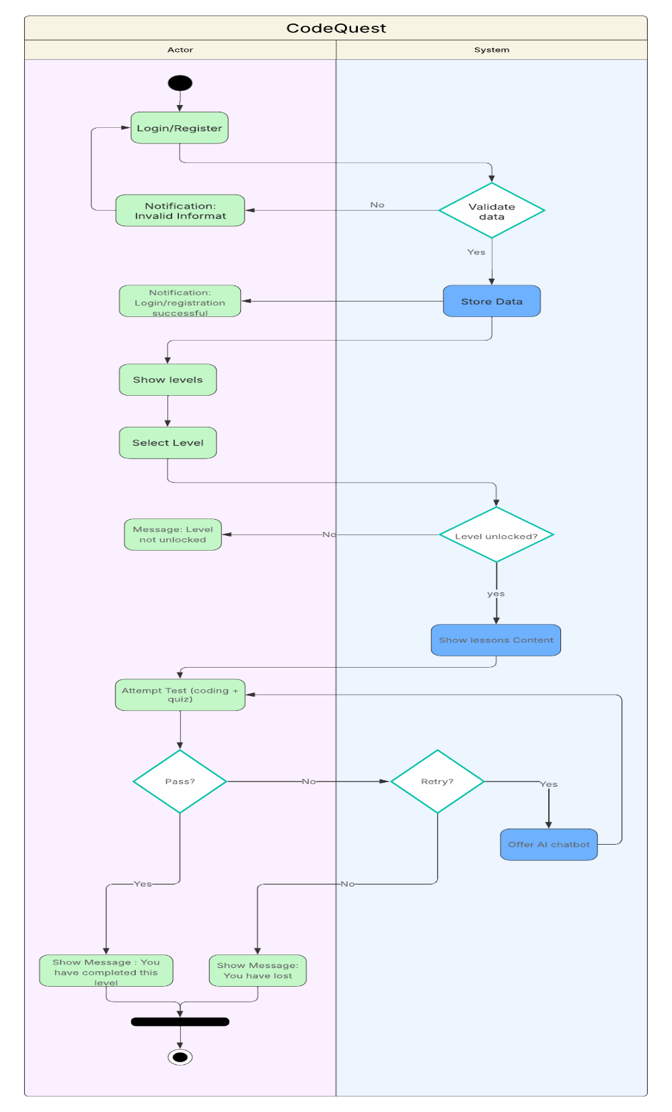
Figure 4Activity Diagram

Sequence Diagram
UML sequence diagrams model the flow of logic within your system in a visual manner, enabling you both to document and validate your logic, and are commonly used for both analysis and design purposes. (AgileModeling, 2025)
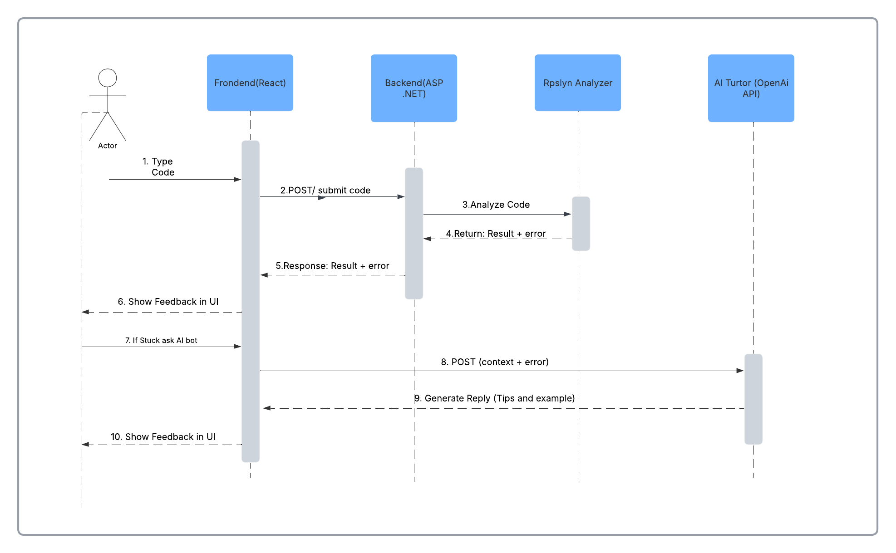
Figure 5: Sequence Diagram

Collaboration Diagram
Collaboration graphs (also called Communication Diagram in UML 2.x) can be used to depict the interaction between objects to carry out the behaviour of a given use case, or a subset of a use case. In addition to the sequence diagrams, the designers employ collaboration in defining and explaining the functions of the objects that execute a given flow of events of a use case. (Visula Paradigm, 2025)
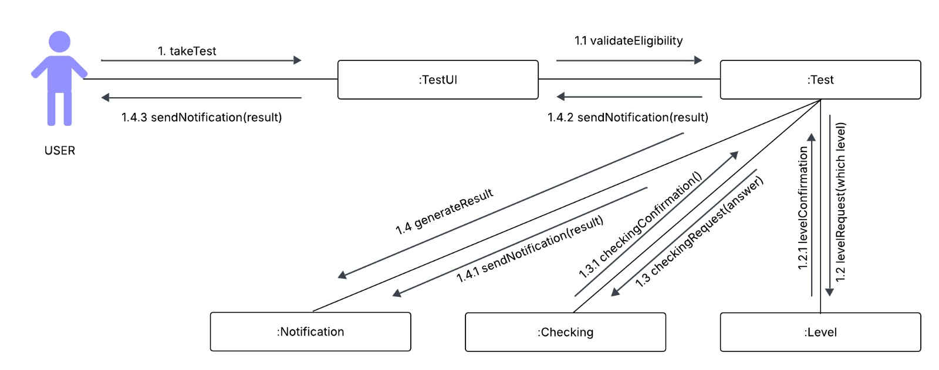
Figure 6: Collaboration Diagram

High-Level Design (HLD)
High-Level Design in software engineering is a conceptual blueprint. Much like an architect's plan for a building, HLD outlines the software system's architecture, its modules, and the interaction between them, all at a high level. (Patil, 2024)
- Use Case 1: Login/Register User
Actor: User (Student or Admin)
Description:
The user logs into the system or creates a new account. The system verifies the provided credentials to ensure authenticity and prevent unauthorized access.

Use Case 2: Start a Level
Actor: Student
Description:
The student selects a level to begin learning. The system loads the lesson content and unlocks the corresponding test. Within the level, students can read lessons and later attempt the test related to that level.

Use Case 3: Lesson
Actor: Student (through Start Level)
Description:
The student views structured learning content such as explanations, examples, and topic descriptions. The lesson prepares the student for the upcoming test.

Use Case 4: Attempt Test
Actor: Student
Description:
The student answers test questions for the chosen level. The system records responses, validates answers, and calculates the test outcome. Tutor help may be triggered if the student needs assistance.

Use Case5: Submit Code
Actor: Student
Description:
The student writes and submits C# code for a test or coding challenge. The system analyses and validates the submitted code, checking syntax and correctness. NPC Tutor support may be provided for debugging or hints.
- Use Case 6: Validating User Code
Actor: System
Description:
The system analyses and evaluates the student's submitted code using internal logic or a compiler. It provides feedback, identifies errors, and determines whether the submission meets the expected behaviour.

Use Case 7: NPC Tutor
Actor: System (as helper)
Description:
An AI-driven tutor provides hints, explanations, or guidance whenever the student struggles during lessons, tests, or code submission. This support only appears when needed or requested.

UML Class Diagram
A Unified Modelling Language (UML) is a model which visually maps out a system architecture that has clear definition of terms and concepts such as system’s classes, their attributes, operations(methods) and the relationships among the objects. (Visula Paradigm, 2025) (Canva, 2025)
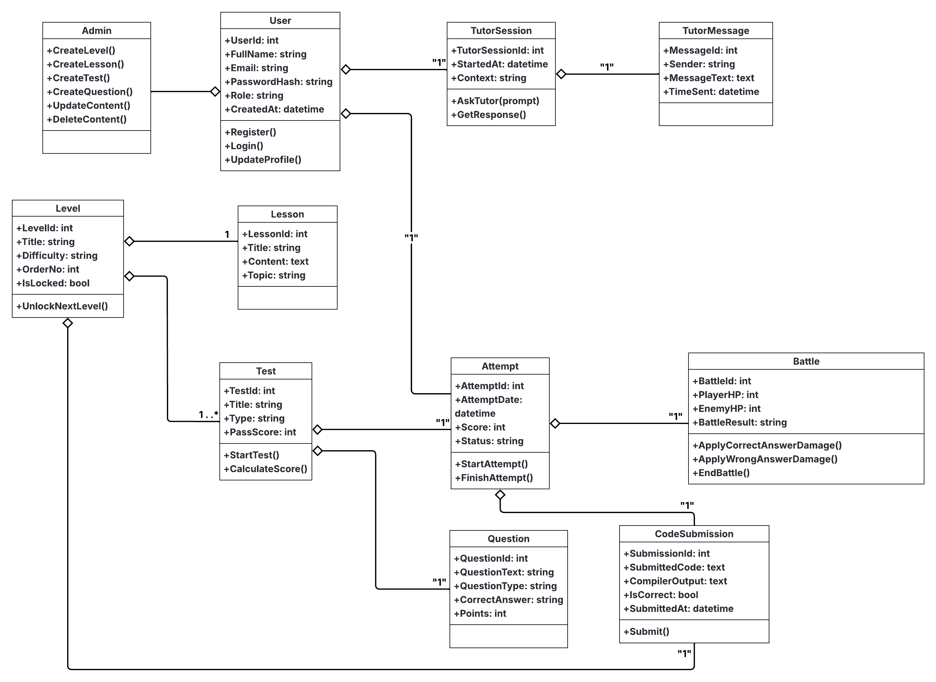
Figure 7: UML Class diagram

Appendix C: To Be Determined (TBD) List
- TBD-01: Final list of all C# topics and number of levels (e.g., 8–10 levels).
- TBD-02: Exact pass criteria for each level (e.g., 70% correct answers + victory in battle).
- TBD-03: Specific external AI provider and pricing plan (OpenAI or alternative).
- TBD-04: Detailed UX design (colors, fonts, exact layouts).
- TBD-05: Exact limit on AI tutor usage per user per day.
- TBD-06: Target browser support list (minimum versions).
- TBD-07: Any additional analytics/reporting requirements for instructors.

References
AgileModeling, 2025. agilemodeling. [Online]
Available at: https://agilemodeling.com/artifacts/sequencediagram.htm#:~:text=Sequence%20diagrams%20are%20the%20most,diagramming%2C%20and%20interaction%20overview%20diagramming.
[Accessed 11 12 2025].
Canva, 2025. Canva. [Online]
Available at: https://www.canva.com/online-whiteboard/class-diagrams/
[Accessed 16 12 2025].
Coursera Staff, 2025. Coursera. [Online]
Available at: https://www.coursera.org/articles/work-breakdown-structure?msockid=3faad288af3262bf37abc40eae8c6315
[Accessed 27 11 2025].
Patil, A., 2024. Orhanergun. [Online]
Available at: https://orhanergun.net/understanding-high-level-design-an-introduction-for-beginners
[Accessed 29 11 2025].
visualparadigm, 2025. visual-paradigm. [Online]
Available at: https://www.visual-paradigm.com/guide/uml-unified-modeling-language/what-is-activity-diagram/
[Accessed 11 12 2025].
Visula Paradigm, 2025. Visual-Paradigm. [Online]
Available at: https://www.visual-paradigm.com/guide/uml-unified-modeling-language/what-is-uml-collaboration-diagram/
[Accessed 22 12 2025].

Prototype:

Wireframes – (User Side)
A wireframe is the skeleton of your digital project. Think of it as the foundation for your website, app, or dashboard. It focuses on layout, and content placement—not on colors, fonts, or any visual polish.(balsamiq)

Register
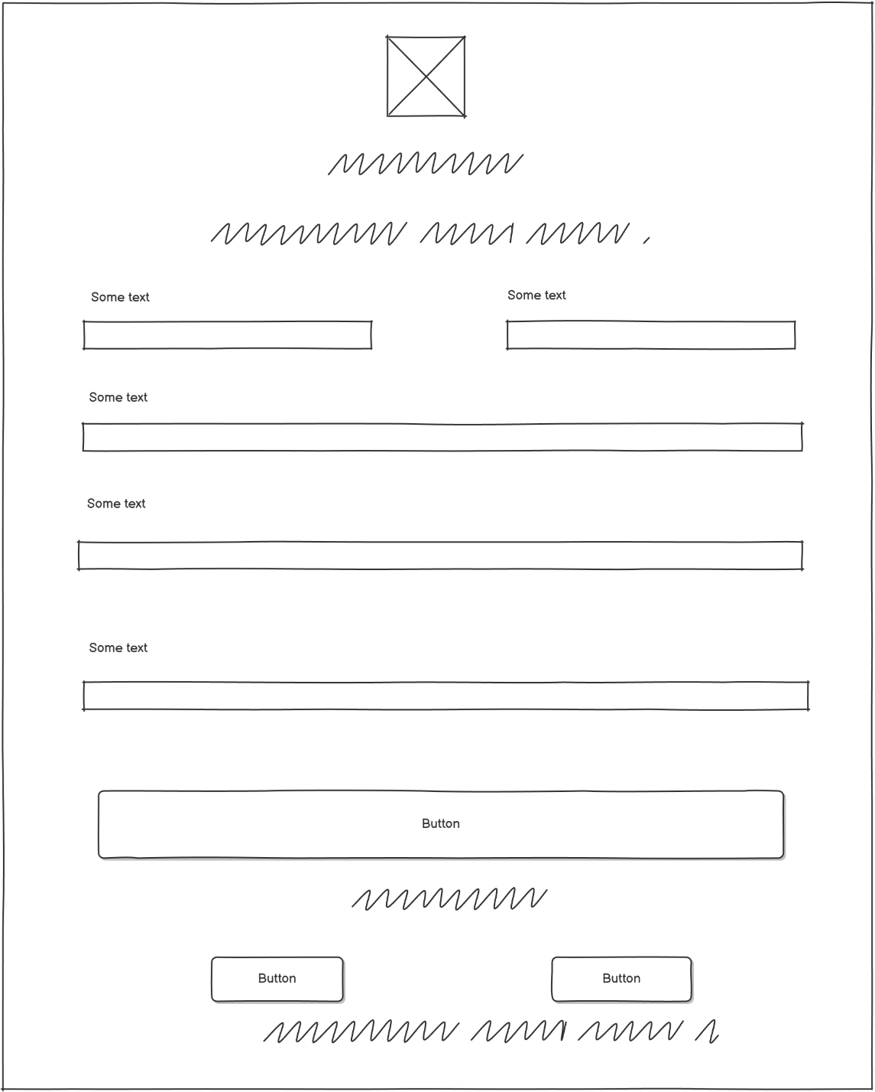
Figure 8:Register Page

Login Page
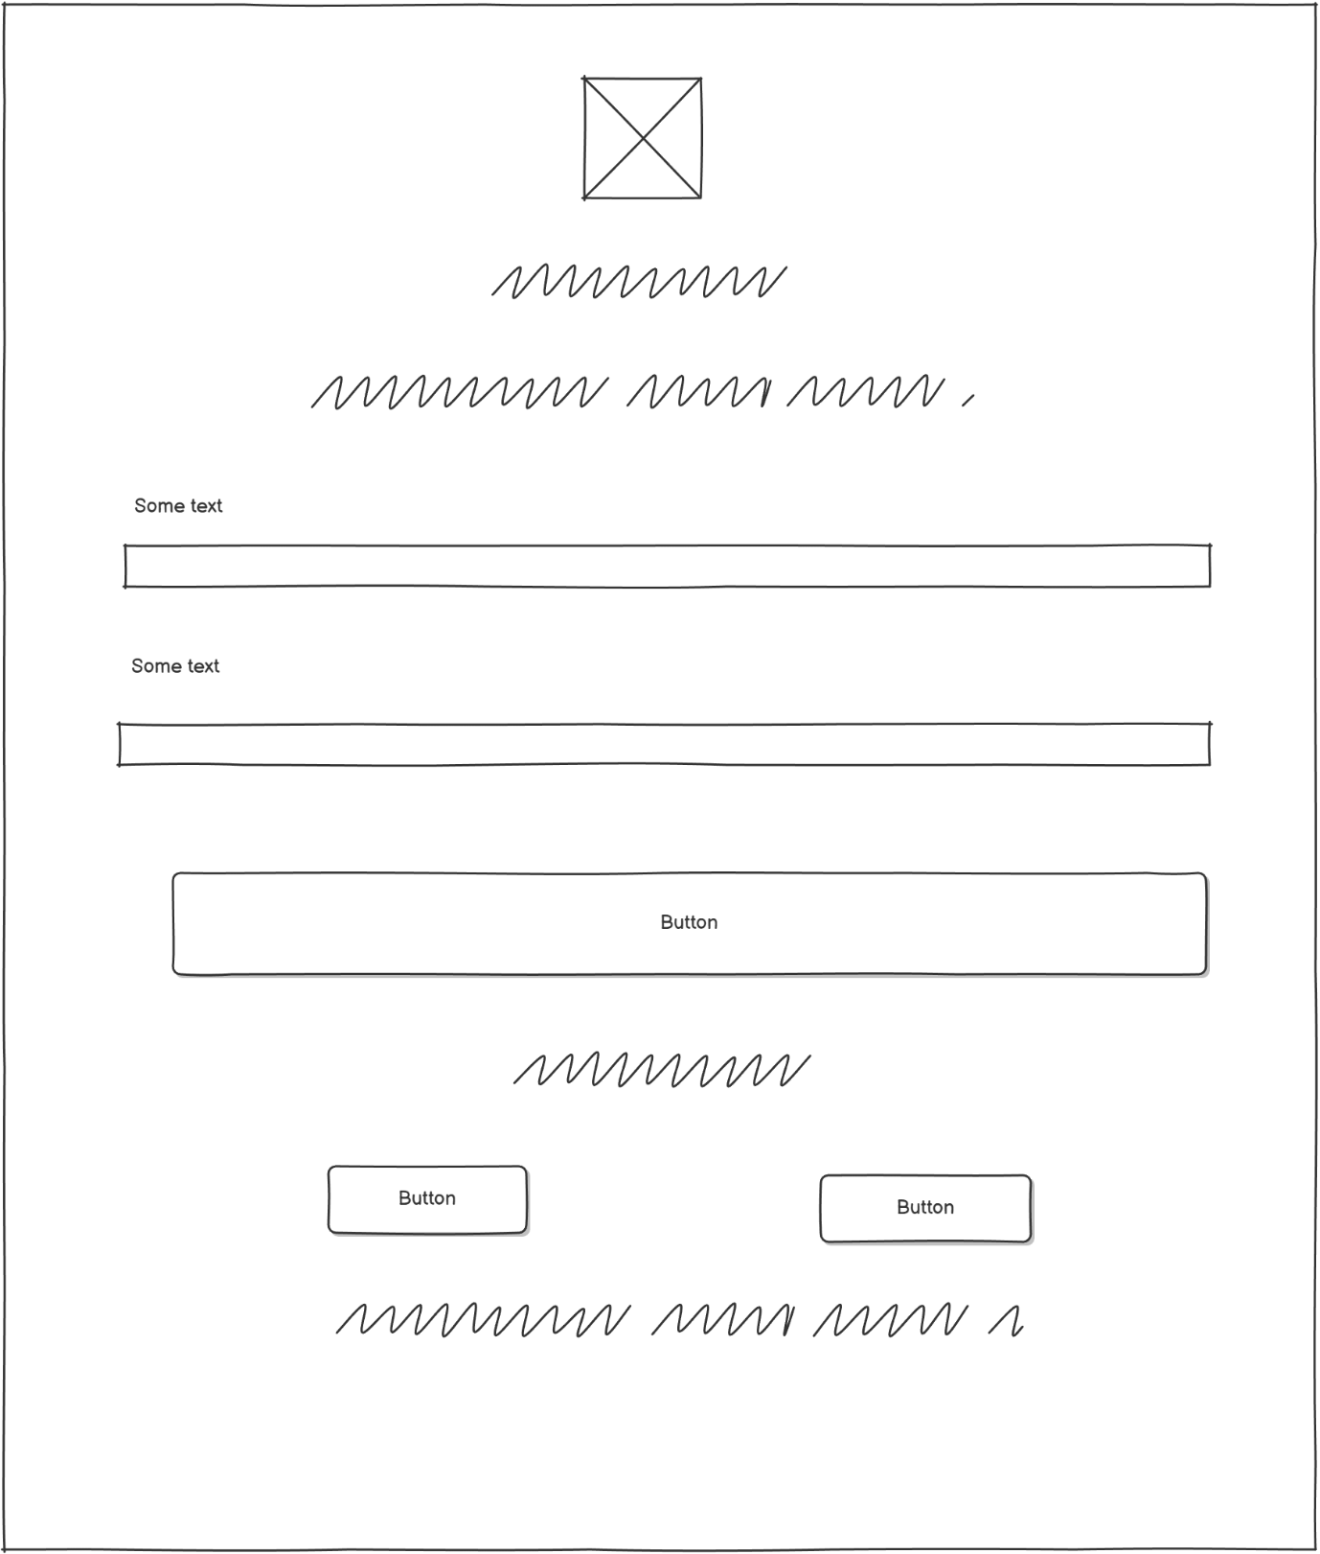
Figure 9:Login Page

Home Page
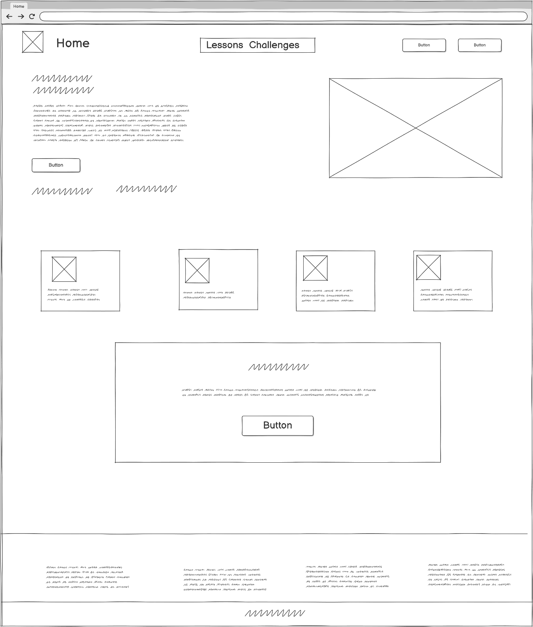
Figure 10: Home Page

Lesson Page
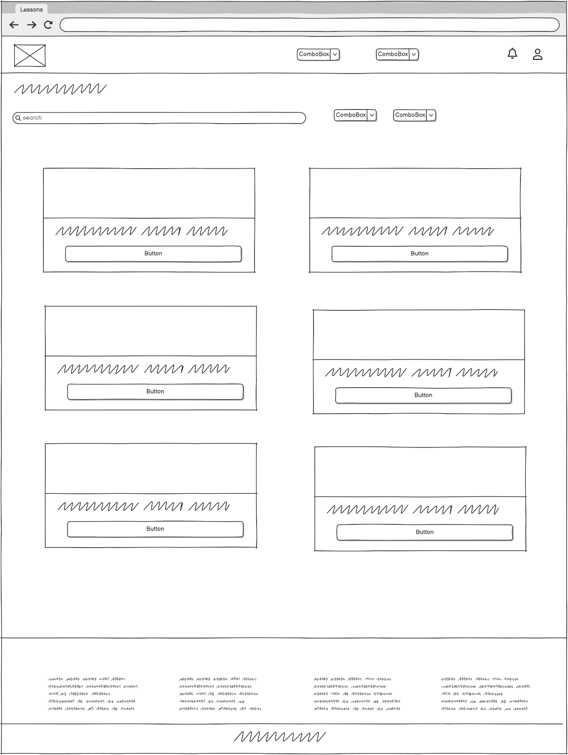
Figure 11: Lesson Page

About Us Page
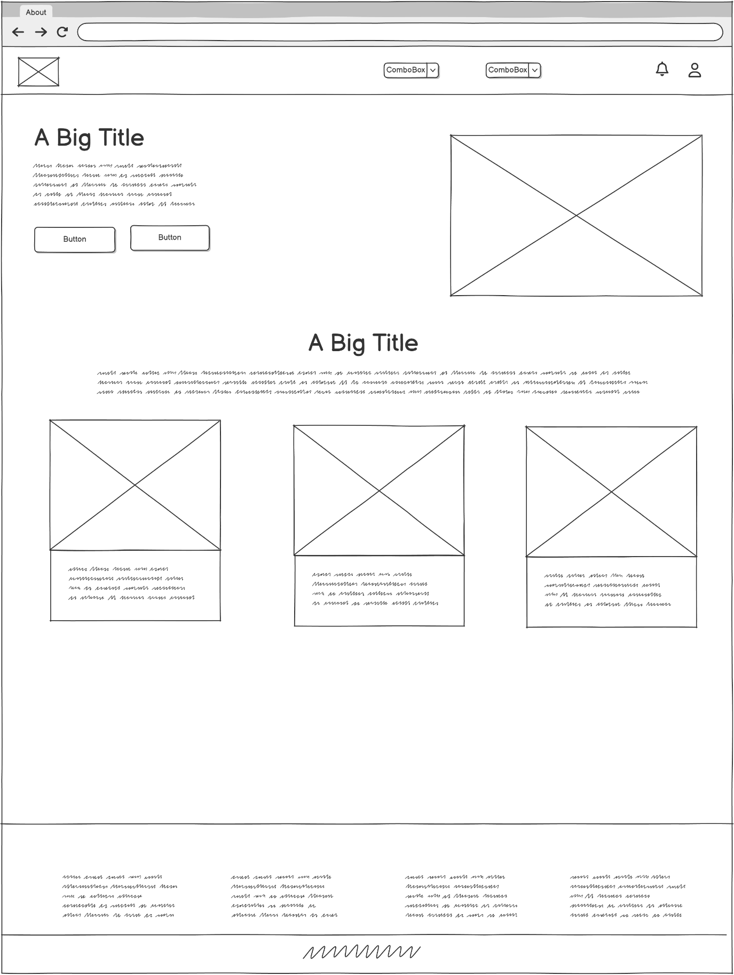
Figure 12:About Us Page

Contact Us Page
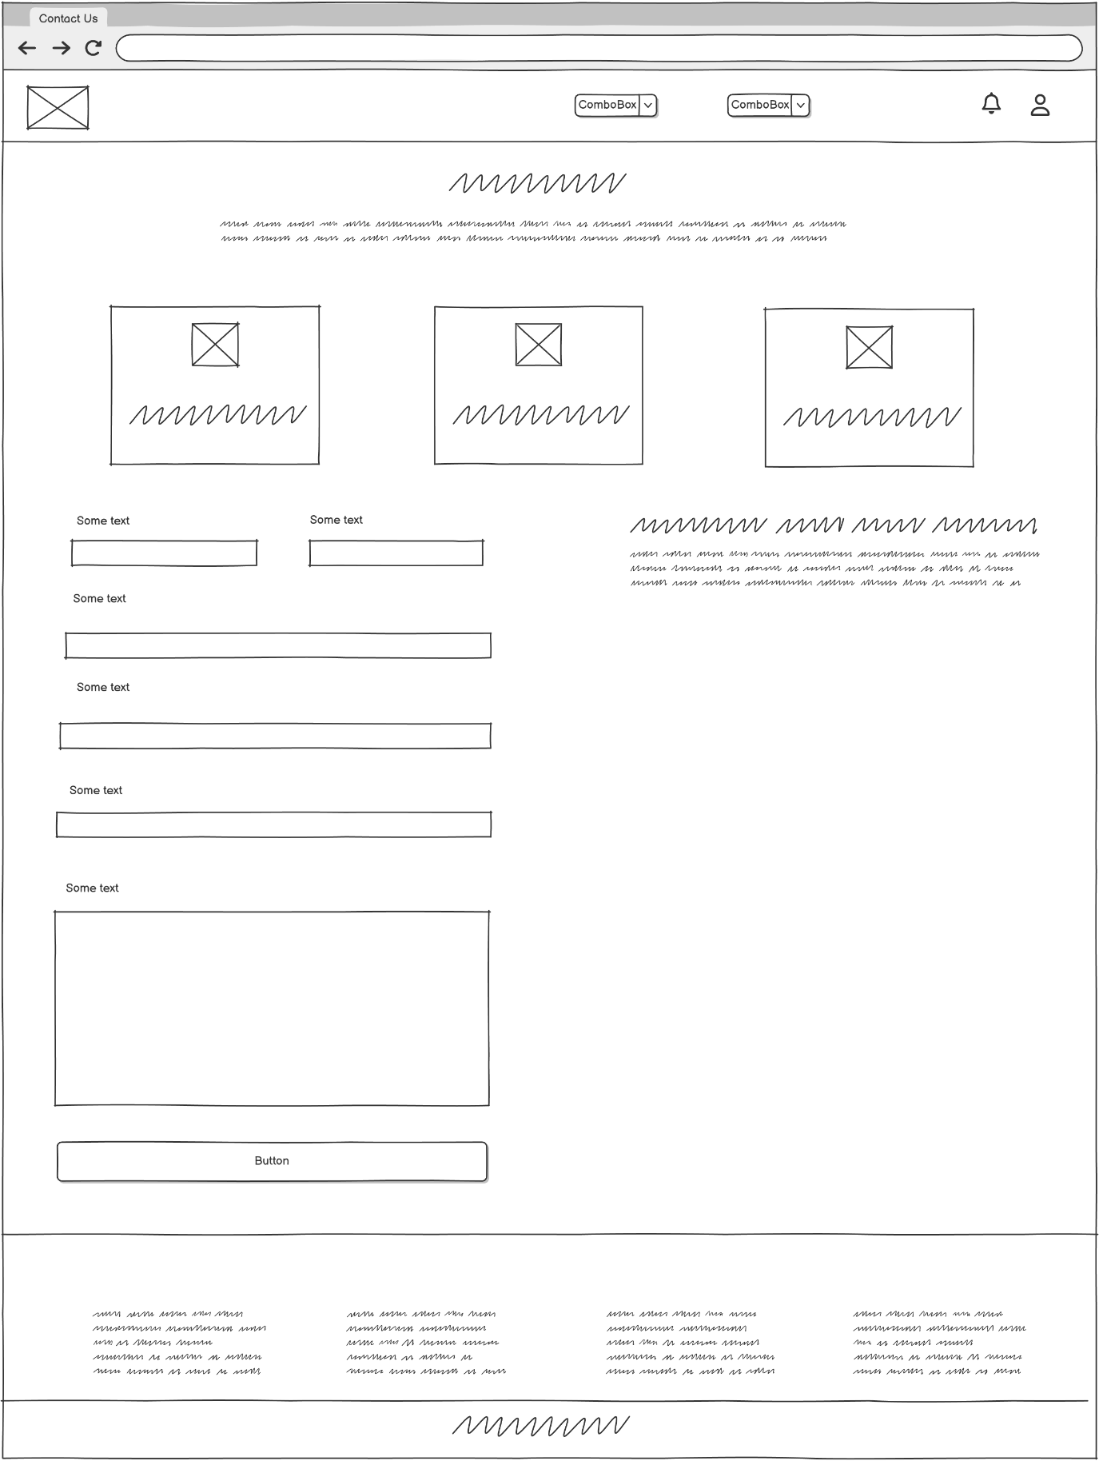
Figure 13: Contact Us Page

Coding Page
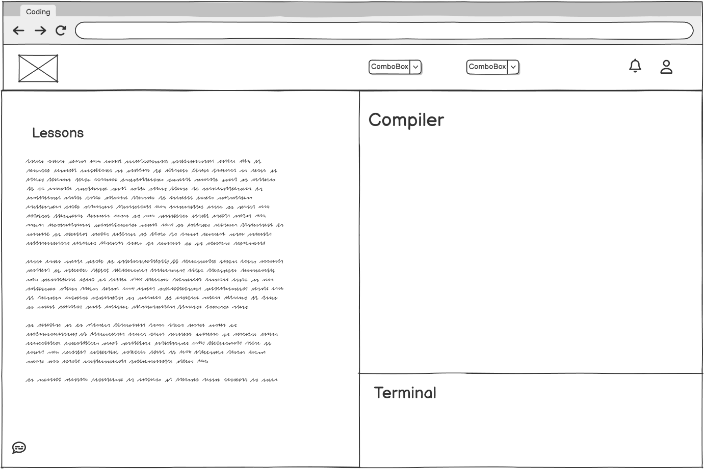
Figure 14:Coding Page

Testing Page
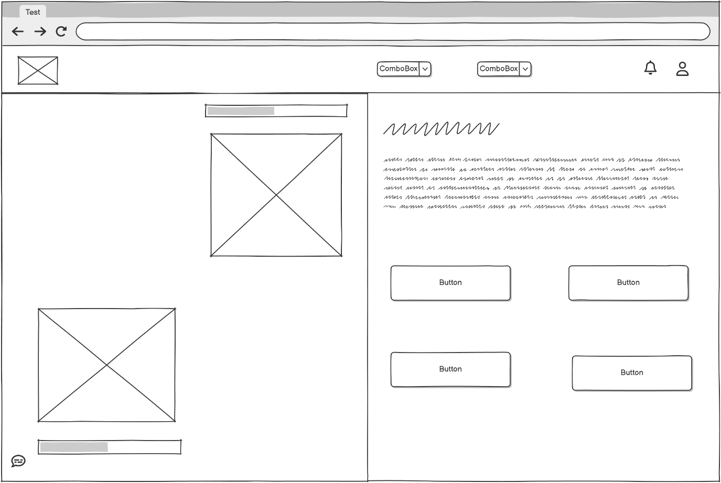
Figure 15:Test Page

Wireframe – (Admin Side)

Admin Dashboard Page
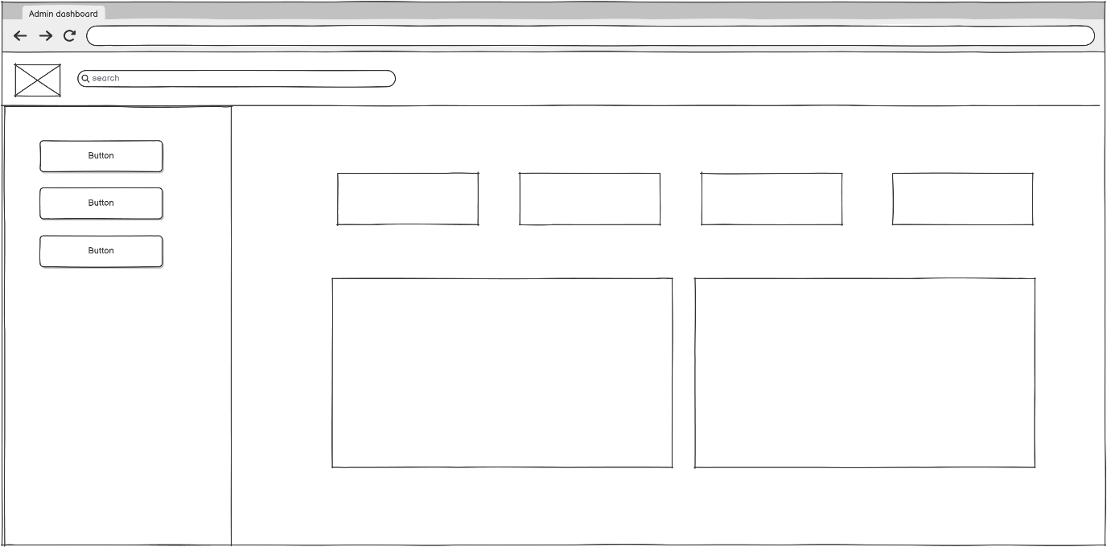
Figure 16: Admin Dashboard Page

Admin Users Page
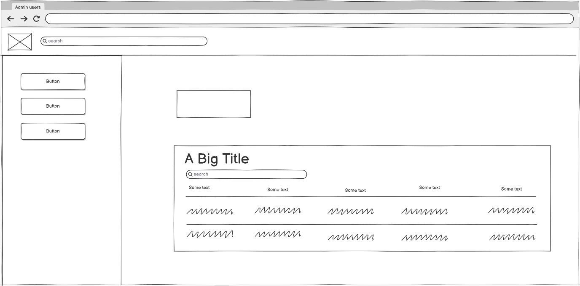
Figure 17: Admin Users Page

